CASE STUDY
Unified AI GTM Agent Platform

EXECUTIVE SUMMARY
Problem: Fragmented GTM tools causing inefficiency and poor visibility.
Solution: Built a unified AI-powered modular GTM platform integrating Sales, Marketing, Support & Analytics.
Outcome: Reduced manual effort by 40% and accelerated campaign execution by 60% with real-time intelligence.

1. Problem Statement

Industry / Customer Context
Sector | B2B Go-To-Market (Sales + Marketing + Support)
Target Users | Growth-stage startups & mid-sized teams
Geography | Multi-region digital operations
Team Size | 10–100 GTM stakeholders (SDR, Marketing, Support, Ops)

Core Problem Identified
GTM workflows were fragmented across multiple disconnected tools — CRM, campaign tools, analytics dashboards, support inboxes, and calling systems — with no unified intelligence layer.

Supporting Data Points (Baseline Before Intervention)
- 6–8 tools used daily across teams
- 35–45% time spent on manual data entry & reconciliation
- 20–30% lead data duplication across systems
- 2–3 day lag in cross-team handoffs
- No unified ICP scoring or funnel intelligence

Why It Mattered
- Slow GTM execution speed
- Poor visibility on funnel performance
- Inconsistent customer engagement
- High operational overhead
- Limited data-backed decision-making

Strategic Risk: Reduced competitiveness in fast-moving markets due to lack of automation and intelligence.

2. Impact of the Problem
(Functional, Emotional & Social Pain)

Operational Pain
- Manual lead syncing between CRM, campaigns, and support
- Inbound emails/WhatsApp not auto-routed to pipeline
- Campaign personalization done manually
- Voice call logs not integrated with analytics
Result: 30–40% productivity drain across GTM roles.

Emotional Impact
- Leadership lacked real-time funnel visibility
- Teams operated in reactive "firefighting mode"
- Decision-making based on intuition, not insights

Social / Organizational Consequences
- Friction between Marketing & SDR over lead quality
- Support tickets not linked to sales context
- Misalignment on ICP targeting

Cost of Inaction
If unchanged:
- 25–35% slower pipeline velocity
- Increased CAC due to poor targeting
- Scaling beyond 100K leads becomes operationally unstable
- AI adoption gap vs competitors widens

3. Solution Provided
(Pain Relievers & Gain Creators)

Solution Overview
Developed a Unified AI GTM Agent Platform integrating Sales, Marketing, Support, Research, and Analytics into a modular microservices architecture with shared context intelligence.

Key Features Implemented
1. Leads & Pipeline Hub
→ Auto-capture inbound email & WhatsApp
→ Kanban pipeline with contextual AI scoring
Pain Relieved: Manual lead routing eliminated

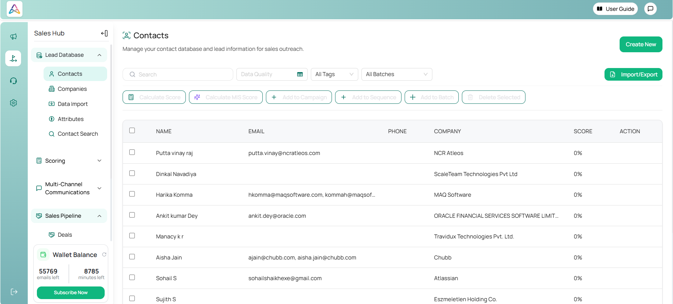

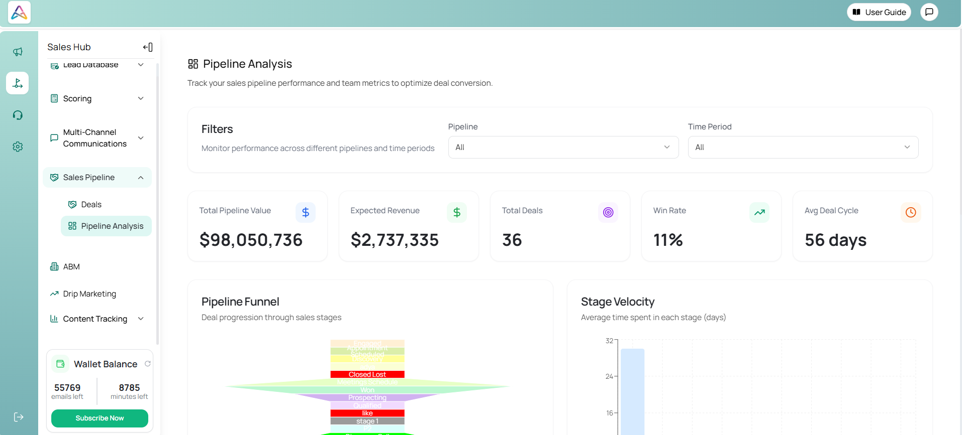

2. Audience & Scoring Hub (Research Agent Embedded)
→ AI-based ICP segmentation
→ Fit + Intent scoring
Gain Created: Improved targeting precision

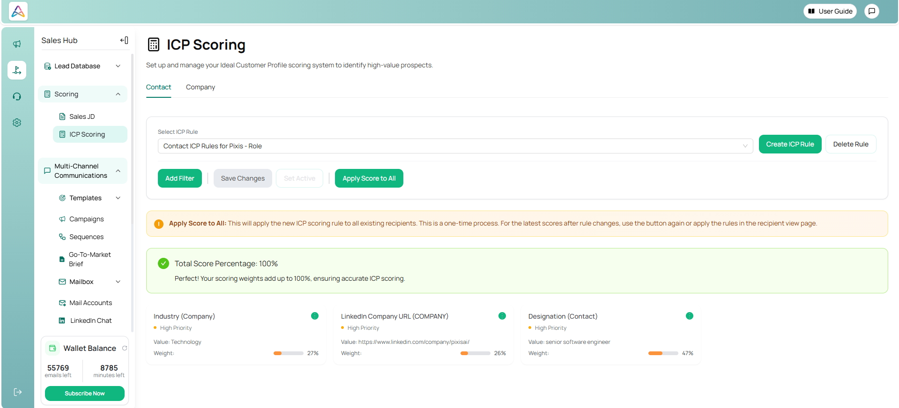

3. Content & Campaign Hub
→ Multi-channel sequence builder
→ AI-generated brand-aligned content
Efficiency Impact: Reduced campaign creation time by 60%
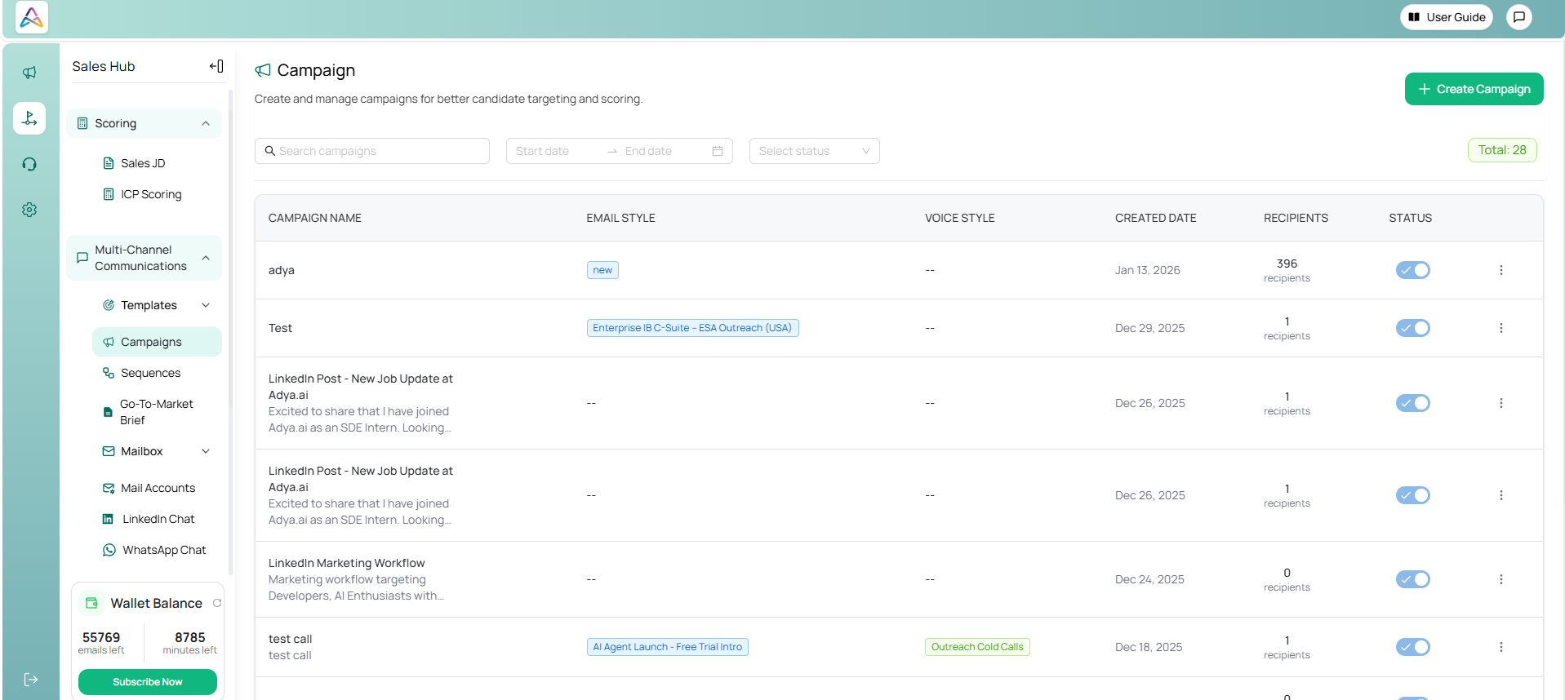

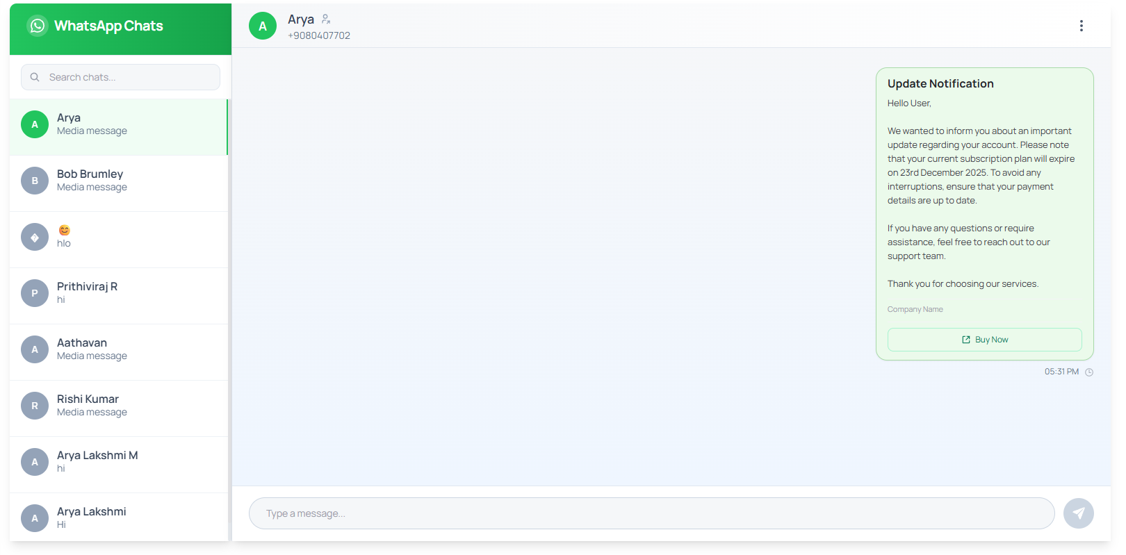

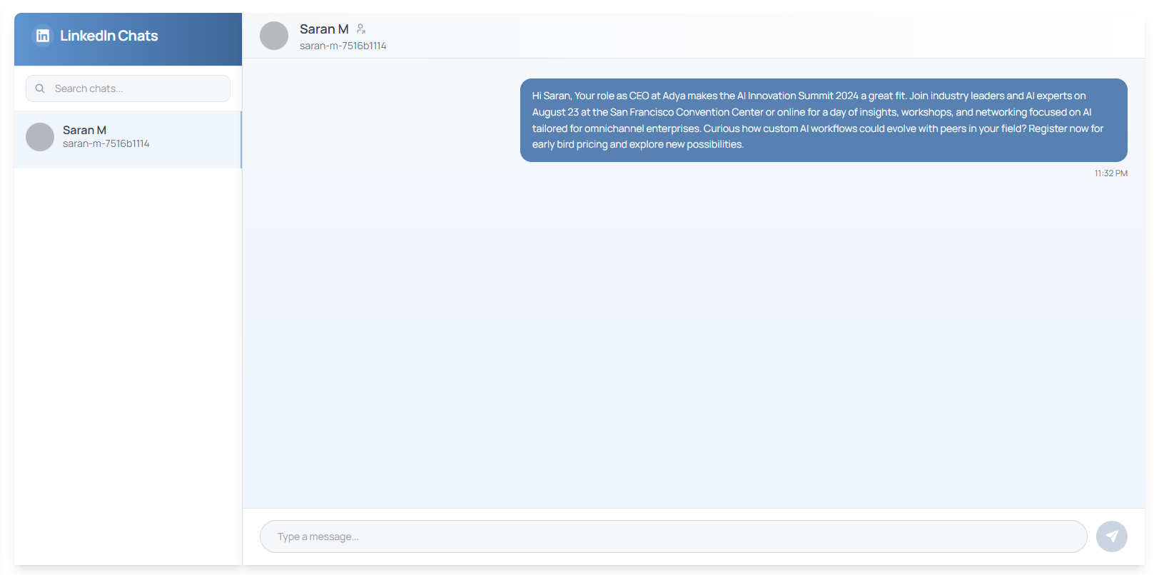

4. Engagement & Delivery Hub
→ Unified email, LinkedIn, WhatsApp, and call logs
Gain Created: 360° engagement visibility

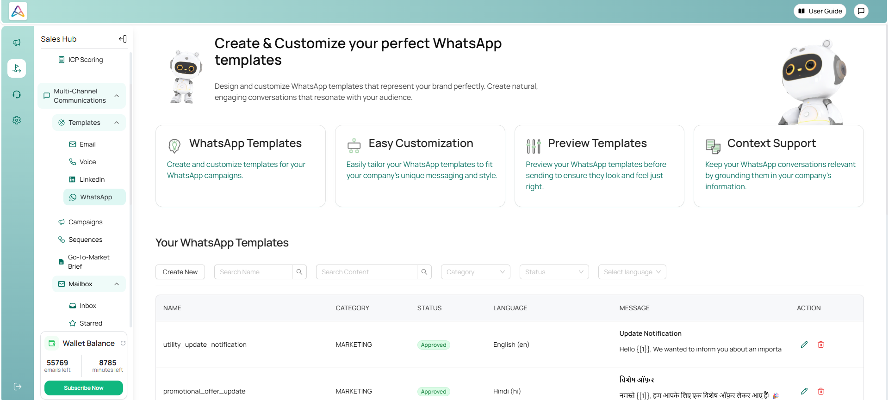

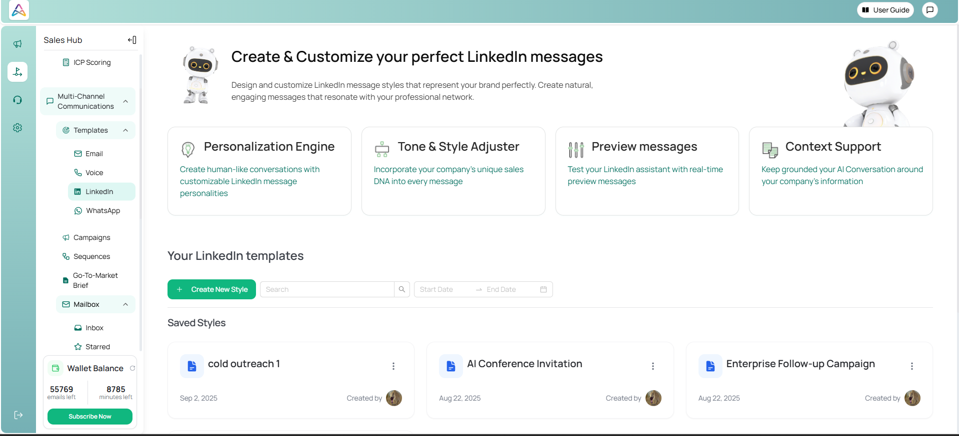

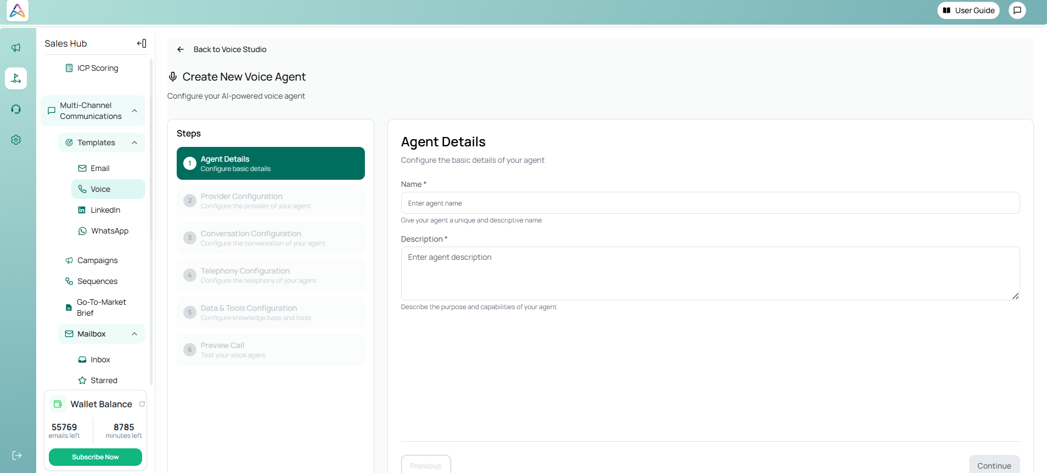

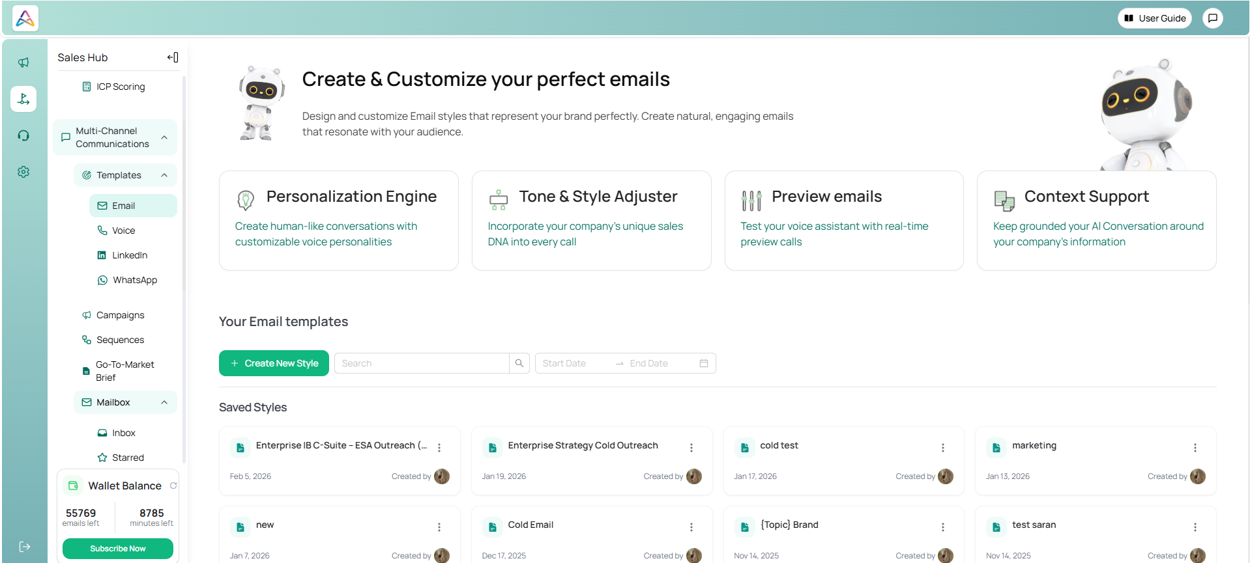

5. Dashboard & Insights Hub (Data Analyst Agent)
→ Funnel analytics
→ Velocity & conversion intelligence
→ Automated GTM recommendations
Impact: Real-time decision-making layer

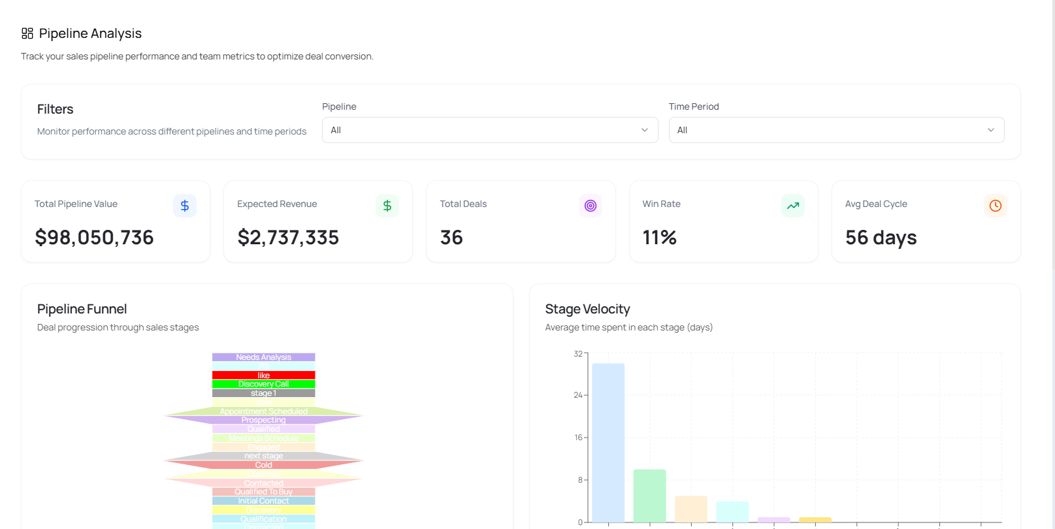

6. Voice-to-Voice Agent (V2V)
→ AI-powered calls via Twilio + LiveKit
→ Context memory stored in Milvus
Gain Created: Automated outbound calling intelligence

AI Agent Architecture
The platform is powered by three core AI agents — each purpose-built for a distinct GTM function and operating in sync across the shared intelligence layer.

7. Marketer Agent – Content Creation & Content Distribution
→ Content Creation: AI-generated brand-aligned copy across formats (blogs, ads, emails, social)
→ Content Distribution: Multi-channel publishing across LinkedIn, email, WhatsApp, and web
→ Campaign Sequencing: Automated drip flows with personalization at scale
→ SEO & Keyword Intelligence: Content optimized for discoverability and engagement
→ Performance Tracking: Content engagement metrics fed back into campaign strategy
Pain Relieved: Manual content creation and inconsistent distribution eliminated
Gain Created: Faster go-to-market with consistent, on-brand messaging across all channels

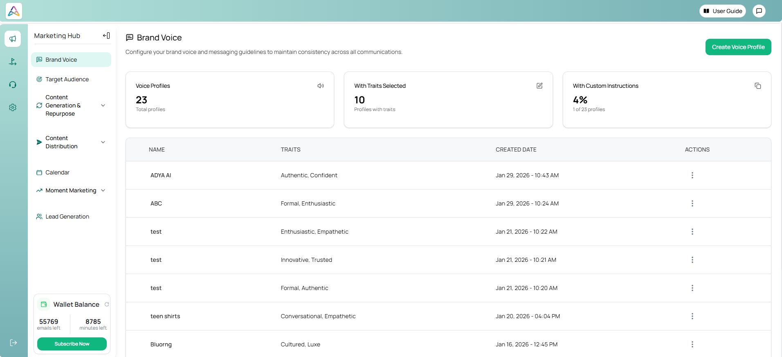

8. Sales Agent – Campaigns, Sales, Lead Generation & Customers
→ Lead Generation: AI-powered ICP identification, enrichment, and scoring
→ Campaign Execution: Automated outbound sequences via email, LinkedIn, and WhatsApp
→ Pipeline Management: Stage-wise funnel tracking with AI-recommended next actions
→ Customer Intelligence: 360° customer context from first touch to closed deal
→ Analytics Layer: Conversion rates, velocity metrics, and revenue forecasting
→ CRM Sync: Real-time data reconciliation across sales tools
Pain Relieved: Disconnected lead gen, manual follow-ups, and siloed sales data
Gain Created: End-to-end sales intelligence from prospecting to close with predictable pipeline visibility
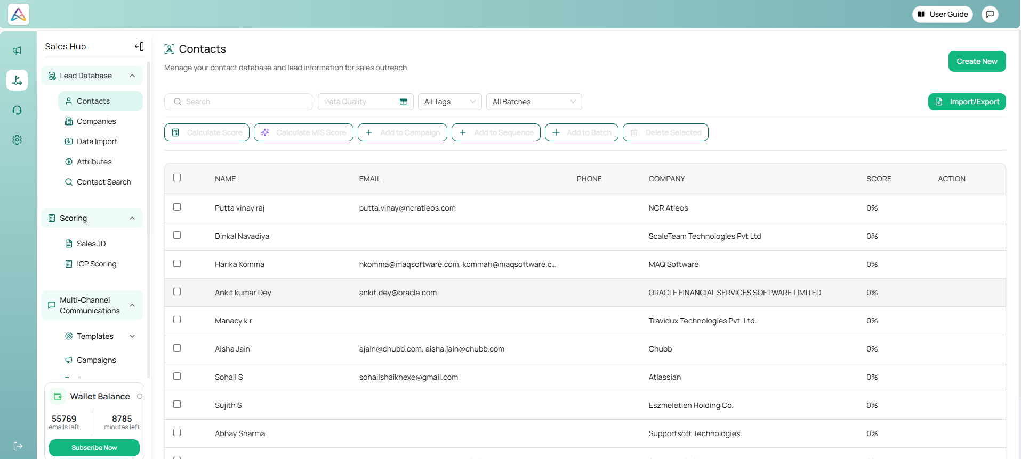

9. Customer Agent – Multi-Channel Engagement & Support
→ WhatsApp: Automated inbound handling, query resolution, and proactive nudges
→ Voice: AI-powered calls via V2V agent with context memory (Twilio + LiveKit)
→ Email: Smart response generation and follow-up automation
→ LinkedIn: Engagement tracking and conversation management
→ Additional Channels: Extensible to SMS, chat widgets, and future platforms
→ Support Layer: Ticket routing, resolution tracking, and escalation management
→ Unified Context: Full conversation history shared across channels for seamless CX
Pain Relieved: Fragmented customer interactions across tools with no shared context
Gain Created: Consistent, personalized customer experience across every touchpoint — from first outreach to post-sale support
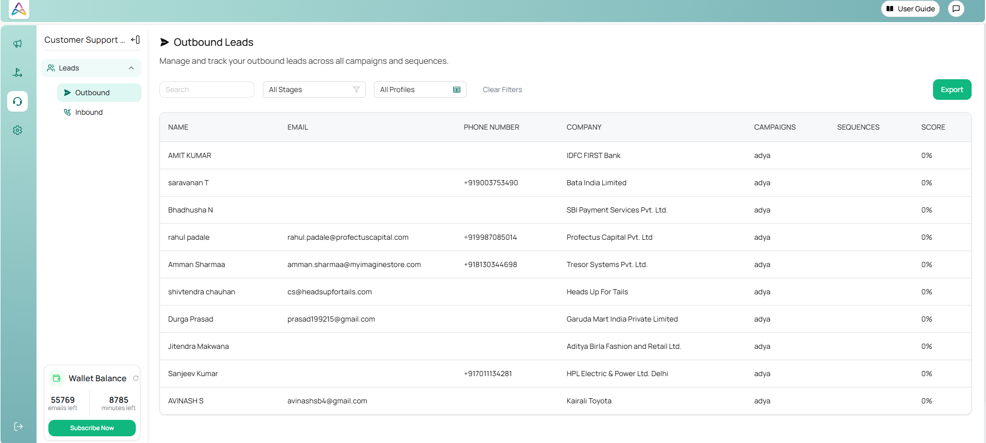

Implementation Approach
- Timeline: 12–16 weeks phased rollout
Phase 1: Core backend + Gateway architecture
Phase 2: Marketing AI & Scoring engine
Phase 3: Voice AI + Integrations
Phase 4: Unified dashboard & analytics layer
Integration Complexity: Moderate–High (multiple APIs, OAuth flows, AI services)

Change Management Strategy:
- Hub-based UI for intuitive adoption
- Guided onboarding
- Modular rollout per team

Technical Capabilities & Architecture
- Microservices architecture (Node.js, Python, Go)
- Central API Gateway orchestration
- MongoDB + Redis caching
- Vector memory via Milvus
- AI layer powered by Azure OpenAI
- Web intelligence via Jina AI
- AWS S3 for secure file management
Scalable to:
- 100K+ leads
- 10+ active campaigns
- <2s analytics query response time

4. Outcome (Quantified Results)

Measurable Results
Metric | Result
Reduction in manual GTM operations | 40%
Faster campaign creation cycle | 60%
Improvement in pipeline visibility | 35%
Reduction in cross-tool switching | 50%
Faster research & ICP enrichment | 70%

Strategic Impact
- Improved GTM execution speed
- Better ICP targeting accuracy
- Centralized intelligence layer
- AI-driven personalization at scale
- Competitive differentiation via automation

Human Impact
- Reduced operational stress
- Improved collaboration between Sales, Marketing & Support
- Leadership gained real-time decision dashboards
- Teams shifted from reactive to proactive execution

